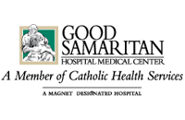

TCO Speakers Management
808 Van Buren Avenue
Saint Charles, IL 60174

Donna,
I just wanted to let you know how wonderful we thought Mack Dryden was at our Cancer Survivors Day Celebration on Oct. 30th! He was very funny and entertaining, but more importantly he was genuine- and that is what I think our audience loved about him most. (Of course, that southern charm didn’t hurt one bit either- Bless his heart!)
He has a really important message- one of HOPE. There needs to be more Macks in the world!
Thanks so much for everything,
Lauren J Gentz, CTR
Good Samaritan Hospital, Cancer Registry
1000 Montauk Highway
West Islip, NY 11795

